KT document for Octopus

Octopus is the deployment tool used for load balancing when the server are under repair for security patches and various other activity

We mainly use Octopus when we get a Deployment plan. The Deployment plan is of two types

1. Hot Fix: In this change plan there are minor changes to the application. It is not mandatory to report to IMOC TEAM for hotfixes.
2. Trend Deployment: when there is a major change in the application. We have to report to database team called as IMOC TEAM.

There are three application:

1. Carnival AU
2. Carnival UK
3. Carnival US

There are various stages in Octopus

1. PROD STAGING
2. PROD STAGING NETWORK
3. PROD FARM A
4. PROD FARM B
5. PROD DCC
6. PROD PREVIEW

PROD STAGING NETWORK: We have the code binary in this stage. When the plan is in this stage the team will raise a ticket for the same and plan the deployment dates. (For the change Request ticket please read Service now KT session).

Then we will create a Maintenance window in Keynote (For Maintenance window view the keynote KT session).

When the Deployment is mentioned as Farm A Deployment that doesn’t mean to bring down the HQ Carnival Farm A server from the following screenshot.

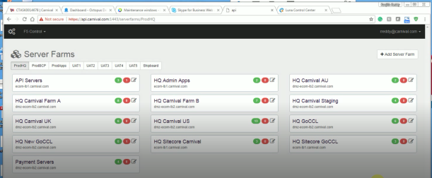

Farm A means a complete set of server which they want to deploy (FARM A server,API SERVER ,Demon Server, payment server).

To take down the server we need to select the server and then click on force offline they should check for no load on the server.

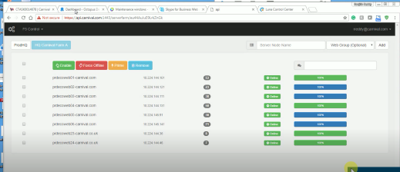

We have to promote to code from Staging to network staging before we pull down the server.

When the staging Network is successful we have to carry forward that to PROD Farm A. The server which we need to bring out are listed in the change request documents.

We have to perform load balancing here. We should be careful that when we bring the PROD A is brought down for patches then all the request will be diverted from PROD A to PROD B.

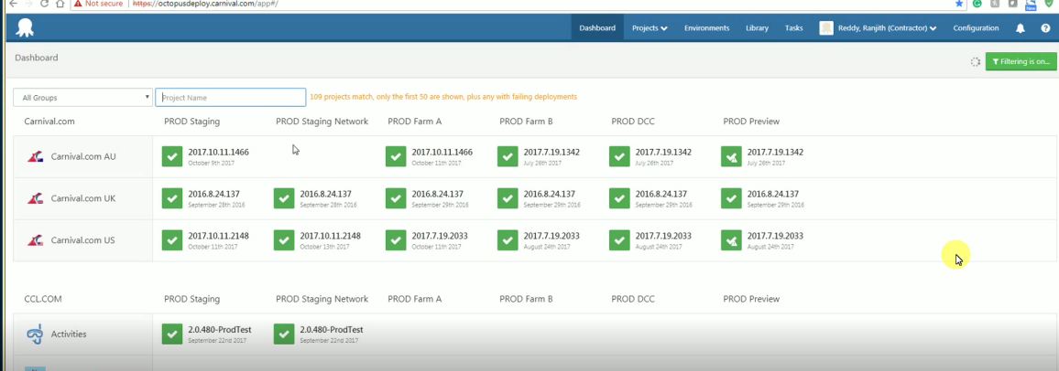

Now click on the Prod Staging Network -> promote ->PROD FARM A it will promote with the Assignee then assign it to yourself and in the notes we have to give the change request number.

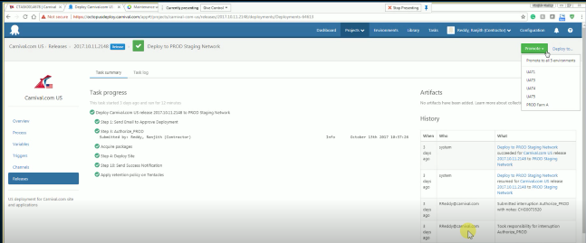

Now the package will be deployed to Farm A server. It will notify us when the deployment is successful.

When the deployment is successful we need to again pull the serve up by click on the Prime button and then enable.

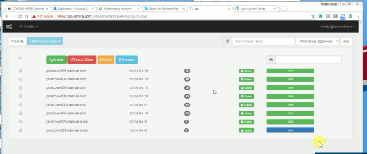

We need to check for 100 % and Green and they will see the load coming and notify the same to the developers.

Then do the same for Farm B server take them down check for their load is zero.

And then when the deployment is successful again click for the Prime button and check the 100% and check for the load.

PROD DCC /PROD PREVIEW: If the new code is completely working fine and completed successfully then we will completely switch the code from Farm B to PROD DCC and then to PROC PREVIEW.

We don’t have to make changes in the server in this stages.

Checking the list of server to bring down:

Double click on the Staging Network of the specific domain

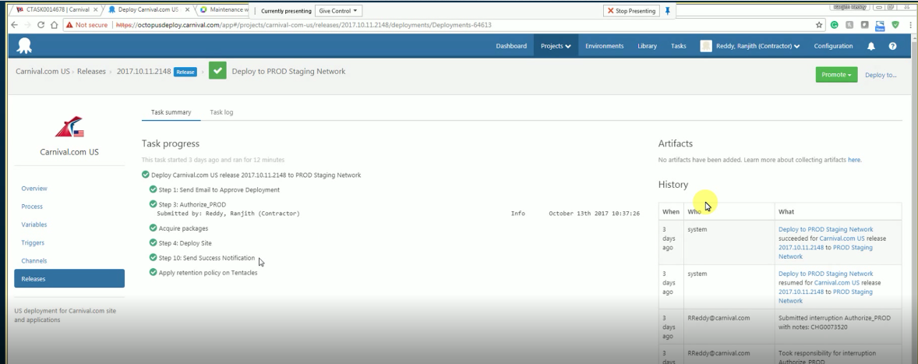

Then click on Task Log there we can see the list of all the server that we need to bring down

